Secure Authentication and Authorization System

Software Requirements Specification (SRS)
Version 1.0

Upeksha Kavindu
Bachelor of Science (Hons) in Software Engineering
Technologies Used
Frontend
- React.js
- React Router DOM
- Axios
- Context API
- Tailwind CSS
Backend
- Java 17
- Spring Boot 4
- Spring Security 6
- JWT Authentication
- MongoDB
- Maven
Security Technologies
- BCrypt Password Hashing
- JWT Access Tokens
- Refresh Tokens
- Email Verification
- Password Reset
- Role-Based Authorization
- Rate Limiting
- Swagger OpenAPI
Date
July 2026

Abstract
Modern web applications require secure authentication and authorization mechanisms to protect sensitive user information and prevent unauthorized access. Traditional session-based authentication systems often struggle with scalability, stateless communication, and secure API access in distributed environments.
This project presents a Secure Authentication and Authorization System developed using Spring Boot, Spring Security, JWT (JSON Web Tokens), React.js, and MongoDB. The system provides a complete authentication solution suitable for modern RESTful applications by implementing secure user registration, login, email verification, password recovery, refresh token management, and role-based access control.
The backend follows a layered architecture consisting of Controller, Service, Repository, and Security layers to ensure maintainability and scalability. Spring Security is configured to protect all secured endpoints while JWT provides stateless authentication without requiring server-side session management. Passwords are securely stored using “BCrypt” hashing, and refresh tokens enable seamless user sessions without requiring repeated logins.
The frontend is developed using React.js and communicates with the backend through REST APIs using Axios. Protected routes ensure that only authenticated users can access restricted resources.
This project demonstrates enterprise-level authentication practices and modern security standards while providing a scalable foundation for integration into larger web applications.

Table of Contents
- Introduction
- Problem Statement
- Objectives
- Scope of the System
- Functional Requirements
- Non-Functional Requirements
- Technology Stack
- System Architecture
- Authentication and Authorization
- Database Design
- Backend Design
- Frontend Design
- API Documentation
- Security Features
- Deployment Guide
- Testing
- Future Improvements
- Conclusion
- References
- Appendix

Chapter 1
Introduction
1.1 Background
Authentication is one of the most critical components of modern software systems. Every application that stores user information must verify the identity of users before granting access to protected resources. Without proper authentication and authorization mechanisms, applications become vulnerable to unauthorized access, data breaches, and various cyber attacks.
Traditional web applications often relied on session-based authentication, where the server maintained user sessions after login. While effective for monolithic systems, session-based authentication introduces scalability challenges in distributed systems, cloud environments, and RESTful APIs.
To address these limitations, modern applications increasingly adopt token-based authentication using JSON Web Tokens (JWT). JWT enables stateless authentication by embedding user identity and authorization information within digitally signed tokens, eliminating the need for server-side session storage.
Spring Security provides a comprehensive framework for implementing authentication and authorization in Java applications. When combined with JWT, BCrypt password hashing, refresh tokens, and role-based access control, developers can build highly secure authentication systems suitable for enterprise environments.
This project implements a complete authentication and authorization solution using Spring Boot, Spring Security, JWT, MongoDB, and React.js.

1.2 Purpose of the System
The primary purpose of this project is to develop a secure authentication and authorization system capable of protecting REST APIs while providing a seamless user experience.
The system allows users to register accounts, verify their email addresses, authenticate using JWT tokens, recover forgotten passwords, refresh expired access tokens, and securely access protected resources based on assigned roles.
The project is designed to serve as a reusable authentication module that can be integrated into future enterprise applications.

1.3 Motivation
Many beginner authentication systems only implement basic username-password login without considering modern security requirements. Such systems are vulnerable to several security issues, including weak password storage, session hijacking, unauthorized access, and insufficient access control.
Modern enterprise applications require advanced security mechanisms such as stateless authentication, encrypted password storage, email verification, refresh token management, and role-based authorization.
This project was developed to gain practical experience with enterprise authentication standards while creating a production-ready authentication module that follows modern software engineering practices.

1.4 Intended Audience
This document is intended for:
- Software Developers
- Backend Developers
- Frontend Developers
- Security Engineers
- System Administrators
- Software Architects
- University Supervisors
- Students studying Spring Security
- Recruiters evaluating backend development skills

1.5 Project Overview
The Secure Authentication and Authorization System is a web-based application designed to provide a complete user authentication solution.
The system consists of a React.js frontend that communicates with a Spring Boot backend through REST APIs. User information is stored in MongoDB, while Spring Security protects all secured endpoints using JWT authentication.
The application supports secure user registration, login, email verification, password reset, refresh token management, and role-based authorization.
The system architecture separates business logic into multiple layers, improving maintainability, scalability, and code organization.

Chapter 2
Problem Statement
As web applications continue to evolve into distributed systems and cloud-native architectures, secure authentication has become increasingly important. Many applications continue to rely on insecure or outdated authentication methods that expose user accounts and sensitive information to cyber threats.
Traditional session-based authentication requires the server to maintain session information for every logged-in user. This increases memory consumption and complicates horizontal scaling across multiple servers.
Additionally, many authentication systems fail to implement important security practices such as secure password hashing, email verification, refresh token management, and fine-grained authorization.
Without these mechanisms, applications become vulnerable to attacks including credential theft, unauthorized API access, brute-force attacks, and account impersonation.
The challenge addressed by this project is to design and implement a secure, scalable, and stateless authentication system that follows modern enterprise security standards while remaining modular enough to integrate into future applications.

Existing System Limitations
Many traditional authentication systems have the following limitations:
- Server-side session dependency.
- Weak or reversible password storage.
- Lack of email verification.
- No refresh token mechanism.
- Poor access control.
- Insufficient input validation.
- Limited scalability.
- Weak protection against unauthorized API access.

Proposed Solution
This project introduces a JWT-based authentication system built with Spring Boot and Spring Security. User passwords are encrypted using “BCrypt” before being stored in MongoDB. Upon successful authentication, the system generates JWT access tokens and refresh tokens to support stateless authentication and seamless session renewal.
Role-based authorization ensures that users can only access resources permitted for their assigned role. Additional features such as email verification, password reset, rate limiting, and centralized exception handling further strengthen the overall security of the application.

Chapter 3
Objectives
General Objective
To develop a secure, scalable, and reusable authentication and authorization system for modern web applications using Spring Boot, Spring Security, JWT, React, and MongoDB.
Specific Objectives
- Develop a secure user registration process.
- Implement JWT-based authentication.
- Provide refresh token functionality.
- Encrypt passwords using BCrypt.
- Verify user email addresses before activation.
- Implement secure password reset functionality.
- Protect REST APIs using Spring Security.
- Restrict access using role-based authorization.
- Create a responsive authentication interface using React.
- Document REST APIs using Swagger.
- Validate all incoming user input.
- Improve security through rate limiting and centralized exception handling.
- Design a modular architecture that supports future expansion.

Chapter 4
Scope of the System
In Scope
The authentication system provides:
- User Registration
- User Login
- User Logout
- JWT Access Token Generation
- Refresh Token Generation
- Token Refresh
- Email Verification
- Forgot Password
- Password Reset
- Role-Based Authorization
- Secure Password Storage
- Protected REST APIs
- User Profile Retrieval
- API Documentation
- Global Exception Handling
- Input Validation
- Rate Limiting
- CORS Configuration
Out of Scope
The current version does not include:
- Social Login (Google, GitHub, Facebook)
- Multi-Factor Authentication (MFA)
- Biometric Authentication
- OAuth2 Client Integration
- Single Sign-On (SSO)
- SMS Verification
- Account Lockout Dashboard
- Audit Log Dashboard
- Multi-Tenant Support
- Identity Federation

Chapter 5
Functional Requirements
User Registration
Users can create a new account by providing valid information. Passwords are hashed with BCrypt before storage, and a verification email is generated.
Email Verification
Accounts remain inactive until the user verifies their email using a unique verification link.
User Login
Users authenticate using email and password. Upon successful login, the system issues a JWT access token and a refresh token.
Token Refresh
When the access token expires, the refresh token can be used to obtain a new access token without requiring the user to log in again.
Password Recovery
Users can request a password reset link via email. A secure token is generated to allow password changes within a limited validity period.
Role-Based Authorization
The system restricts API access according to user roles (for example, ADMIN and USER), ensuring that users can only access resources they are authorized to use.
Protected REST APIs
Sensitive endpoints require a valid JWT token. Unauthorized or invalid requests are rejected with the appropriate HTTP status codes.
User Profile Management
Authenticated users can retrieve and update their profile information.
API Documentation
Developers can explore and test available REST endpoints through Swagger/OpenAPI.
Error Handling
The system returns standardized error responses for validation failures, authentication errors, authorization errors, and unexpected server exceptions.

Chapter 6 – Non-Functional Requirements
6.1 Introduction
Non-functional requirements define the quality attributes of the authentication system. Unlike functional requirements, which specify what the system should do, non-functional requirements describe how well the system should perform. These characteristics ensure that the system remains secure, reliable, scalable, maintainable, and user-friendly throughout its lifecycle.

6.2 Performance Requirements
The authentication system should provide fast and efficient responses for all authentication-related operations.
Performance Goals
Requirement | Target
User Login Response | Less than 2 seconds
User Registration | Less than 3 seconds
JWT Validation | Less than 100 milliseconds
Database Query | Less than 500 milliseconds
Password Reset Request | Less than 2 seconds
Email Verification Request | Less than 2 seconds
Performance Features
- Optimized MongoDB queries using indexed fields.
- Stateless JWT authentication reduces server memory usage.
- Efficient BCrypt hashing with configurable strength.
- Lightweight REST API responses in JSON format.
- Connection pooling for database operations.
- Minimal network latency through optimized API design.

6.3 Security Requirements
Security is the primary objective of this project. The authentication system implements multiple layers of security to protect user data and application resources.
Authentication Security
- JWT Access Tokens
- Refresh Tokens
- Spring Security Authentication
- Stateless Authentication
Password Security
- BCrypt Password Hashing
- Passwords never stored as plain text
- Strong password validation
Authorization
- Role-Based Access Control (RBAC)
- Endpoint-level authorization
- Method-level security
API Security
- Protected REST endpoints
- JWT validation filter
- Unauthorized request blocking
- Secure HTTP status codes
Data Protection
- Email verification before activation
- Secure password reset tokens
- Input validation
- Exception handling
- CORS configuration
- Rate limiting

HTTP Security
- Content Security Policy (CSP).
- HTTP Strict Transport Security (HSTS).
- Prevent Clickjacking using X-Frame-Options.
- Enforce secure HTTP response headers.
- Validate JWT signatures before processing protected requests.

6.4 Reliability
The system should continue operating correctly even when errors occur.
Reliability Features
- Global exception handling.
- Standardized error responses.
- Input validation before business logic execution.
- Secure token validation.
- Automatic handling of expired JWTs.
- Graceful failure when email services are unavailable.

6.5 Scalability
The authentication system is designed to support future growth.
Future scalability includes:
- OAuth2 authentication
- Google Login
- GitHub Login
- Multi-Factor Authentication
- Single Sign-On
- Microservices
- API Gateway integration
- Redis token caching
- Kubernetes deployment
The layered architecture allows these features to be added with minimal impact on existing code.

6.6 Availability
The system should remain available to users at all times except during planned maintenance.
Target availability:99.9% uptime
Current Deployment Environment
- Spring Boot Embedded Server
- MongoDB Database
- React Development Server
- Local Development Environment
Future Deployment Options
- Docker
- Railway
- Render
- AWS EC2
- Microsoft Azure
- Google Cloud Platform

6.7 Maintainability
Maintainability is achieved through modular software architecture.
Code Organization
Backend packages include:
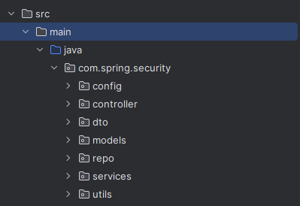

Frontend folders include:
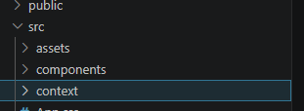
Advantages:
- Easier debugging
- Better readability
- Low coupling
- High cohesion
- Easier feature expansion

6.8 Usability
The authentication interface is designed for simplicity.
Features include:
- Responsive login page
- Responsive registration page
- Password visibility toggle
- Clear validation messages
- User-friendly forms
- Mobile responsive layout

6.9 Compatibility
Supported browsers:
- Google Chrome
- Microsoft Edge
- Mozilla Firefox
- Safari
Supported operating systems:
- Windows
- Linux
- macOS

6.10 Portability
Because Java runs on the JVM, the backend is platform independent.
The React frontend can be deployed independently on:
- Netlify
- Vercel
- Firebase Hosting
- Render

Chapter 7 – Technology Stack
7.1 Overview
Authentication System is developed using modern web technologies following a client-server architecture.

7.2 Frontend Technologies
React.js
React is used to build the user interface.
Responsibilities:
- Login page
- Registration page
- Forgot password page
- Password reset page
- Email verification pages
- Dashboard
- Protected routes
Advantages:
- Component-based architecture
- Fast rendering
- Reusable UI components
- Virtual DOM

React Router
Used for client-side navigation.
Example routes:
/login

/register

/dashboard

/profile

/forgot-password

/reset-password

Axios
Axios manages communication with backend APIs.
Responsibilities:
- HTTP Requests
- JWT Authorization Header
- Error Handling
- Response Interceptors

Context API
Stores:
- Logged-in user
- JWT token
- Authentication state

Tailwind CSS
Used for responsive UI development.
Benefits:
- Responsive design
- Utility-first styling
- Faster development

7.3 Backend Technologies
Java 21
Main programming language.
Benefits:
- Object-oriented
- Platform independent
- Enterprise ready
- High performance

Spring Boot
Backend framework.
Responsibilities:
- REST APIs
- Dependency Injection
- Validation
- Bean management

Spring Security
Handles authentication and authorization.
Responsibilities:
- Login authentication
- JWT validation
- Endpoint protection
- Role management

JWT (JSON Web Token)
Provides stateless authentication.
Each JWT contains:
- User ID
- Username/Email
- User Role
- Expiration Time
Advantages:
- Stateless
- Secure
- Lightweight
- Suitable for REST APIs

MongoDB
Stores:
- Users
- Refresh Tokens
- Verification Tokens
- Password Reset Tokens
Advantages:
- Flexible schema
- High performance
- Easy scalability

Maven
Used for:
- Dependency management
- Build automation
- Plugin management

Swagger OpenAPI
Provides:
- API documentation
- Endpoint testing
- Interactive UI

Java Mail Sender
Used for:
- Email verification
- Password reset emails

BCrypt
Responsible for:
- Password hashing
- Salt generation
- Password verification

7.4 Development Tools
IDE
- IntelliJ IDEA
Database
- MongoDB Compass
API Testing
- Postman
Version Control
- Git
Repository Hosting
- GitHub
Deployment
- Docker
- Railway
- Render

7.5 Technology Stack Diagram
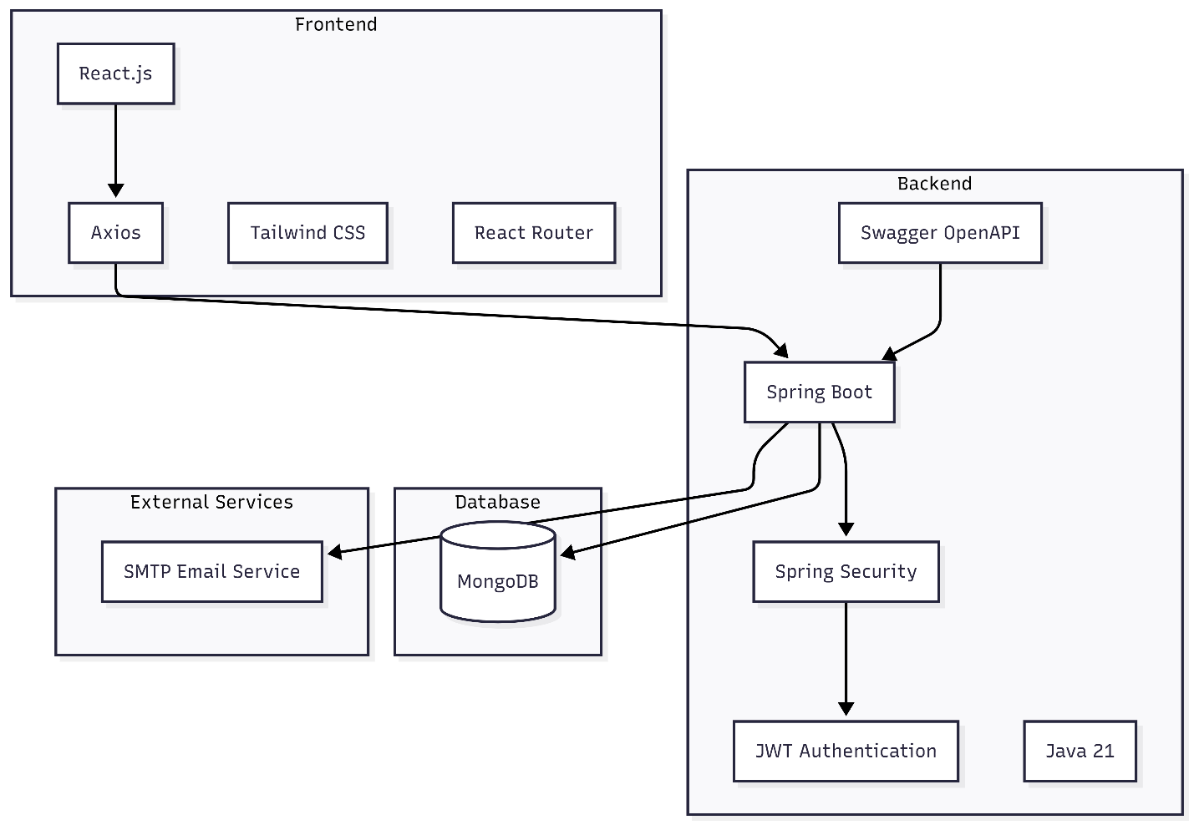

Chapter 8 – System Architecture
8.1 Overview
The system follows a Three-Layer Client–Server Architecture, separating presentation, business logic, and data access. This architecture improves maintainability, scalability, and testability.

8.2 High-Level Architecture

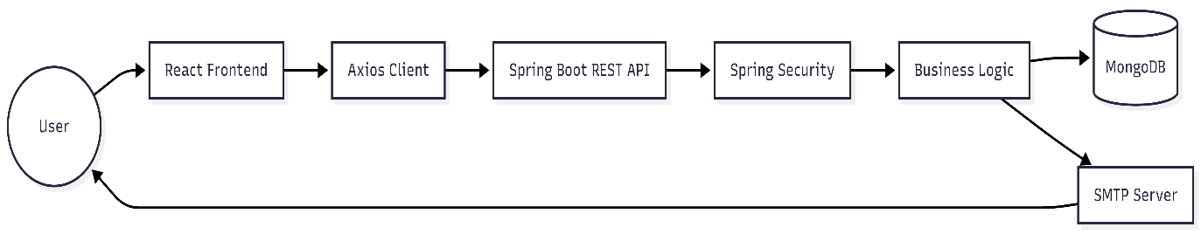

8.3 Presentation Layer
Technology:
- React.js
Responsibilities:
- Render user interface
- Validate form inputs
- Manage authentication state
- Send API requests
- Display responses

8.4 Business Layer
Technology:
- Spring Boot
Responsibilities:
- Authentication
- Authorization
- User management
- Business rules
- Email processing
- Token generation

8.5 Data Layer
Technology:
- MongoDB
Responsibilities:
- Store user information
- Store refresh tokens
- Store verification tokens
- Store password reset tokens

8.6 Security Layer
The Security Layer intercepts every incoming request before it reaches the controller.
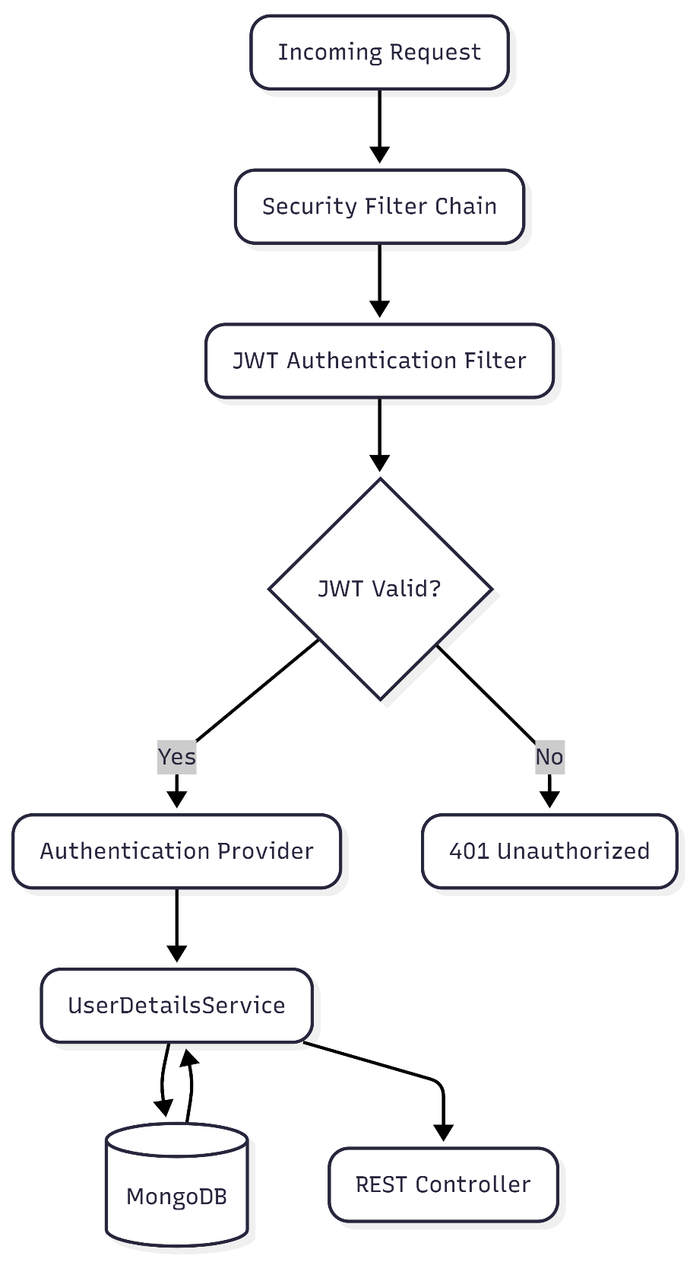
Responsibilities:
- Validate JWT
- Authenticate users
- Verify roles
- Reject invalid requests
- Handle expired tokens

8.7 Spring Security Filter Chain
Every incoming HTTP request passes through the Spring Security Filter Chain before reaching the application's controllers. The filter chain is responsible for enforcing authentication and authorization policies, validating JWT tokens, and preventing unauthorized access to protected resources.
The security workflow is performed in the following order:
- Receive incoming HTTP request.
- Check whether the requested endpoint requires authentication.
- Extract the JWT access token from the Authorization header.
- Validate the token signature and expiration time.
- Load authenticated user details.
- Store authentication information in the Spring Security Context.
- Verify user roles and authorities.
- Forward the request to the appropriate controller.
Requests that fail authentication or authorization are immediately rejected with the corresponding HTTP status codes.
8.8 JWT Authentication Filter
The system implements a custom JWT Authentication Filter that extends Spring Security's “OncePerRequestFilter”. This filter executes once for every incoming request and is responsible for validating authentication tokens before allowing access to protected resources.
Responsibilities of the JWT Authentication Filter include:
- Extracting the Bearer Token from the Authorization header.
- Validating the JWT signature.
- Checking token expiration.
- Loading user information from the database.
- Creating an authenticated Security Context.
- Rejecting invalid or expired tokens.

8.7 Request Processing Flow
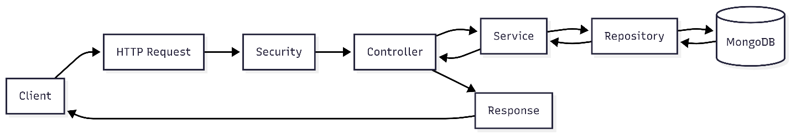
Chapter 9 – Authentication & Authorization
9.1 Overview
Authentication verifies the identity of a user, while authorization determines the resources that an authenticated user is permitted to access.
This system implements a stateless authentication model using JWT, combined with Refresh Tokens and Role-Based Access Control (RBAC).

9.2 Registration Process
- User submits registration details.
- Backend validates the request.
- Password is hashed using BCrypt.
- User record is stored in MongoDB.
- Email verification token is generated.
- Verification email is sent.
- Account remains inactive until verification.
Registration Flow
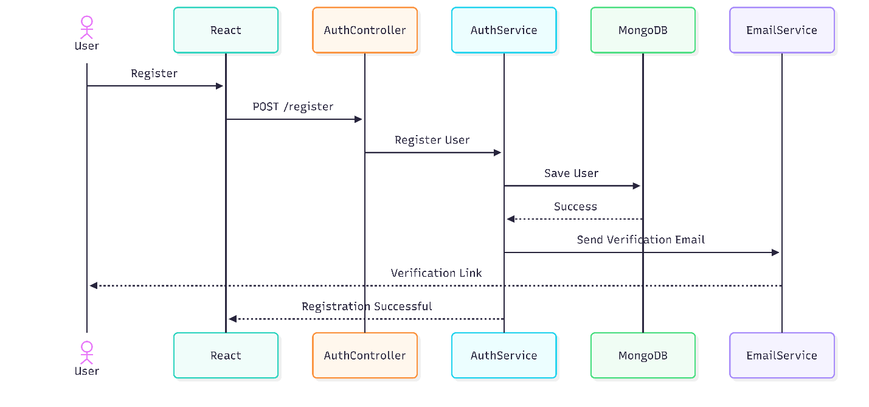
9.3 Login Process
- User submits email and password.
- Spring Security authenticates credentials.
- BCrypt verifies the password.
- JWT Access Token is generated.
- Refresh Token is generated.
- Tokens are returned to the frontend.
- Frontend stores the tokens securely.
Login Flow
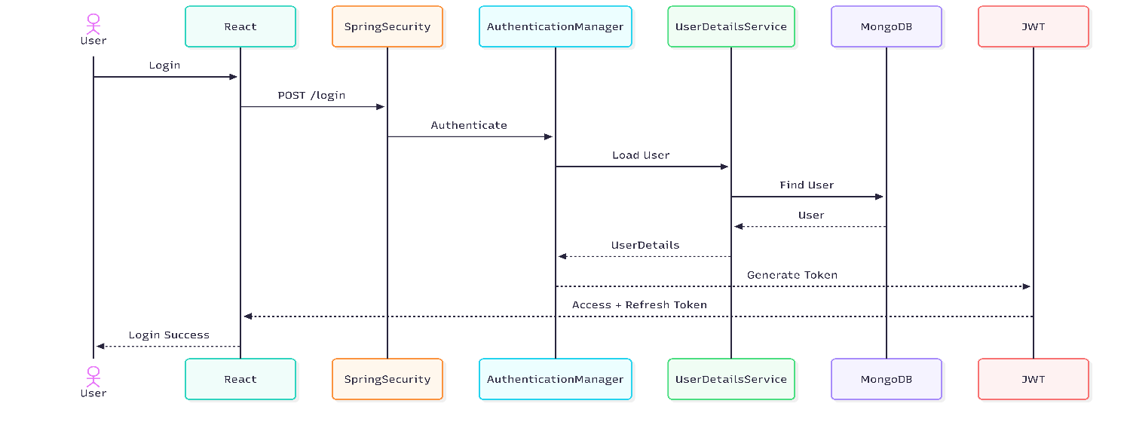

9.4 JWT Authentication
For every protected request:
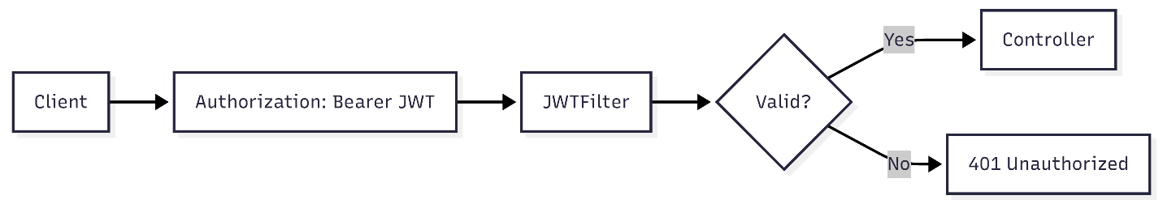
- Frontend sends the Access Token in the Authorization: Bearer <token> header.
- JWT Filter intercepts the request.
- Token signature and expiration are validated.
- User details are loaded.
- Spring Security authorizes the request.

9.5 Authentication Provider
The application uses Spring Security's Authentication Provider mechanism to verify user credentials. During login, the Authentication Manager delegates authentication requests to the configured DaoAuthenticationProvider.
The Authentication Provider performs the following operations:
- Retrieves user information through the UserDetailsService.
- Compares the submitted password with the stored BCrypt hashed password.
- Authenticates valid users.
- Rejects invalid login attempts.
- Returns authenticated user details for JWT generation.

9.6 User Details Service
The “UserDetailsService” acts as the bridge between Spring Security and the application's user database. It loads user information using the provided email address and converts database entities into Spring Security UserDetails objects.
Responsibilities include:
- Loading users by email address.
- Verifying account status.
- Retrieving assigned roles.
- Supplying authentication data to Spring Security.

9.7 Refresh Token Process
When the Access Token expires:
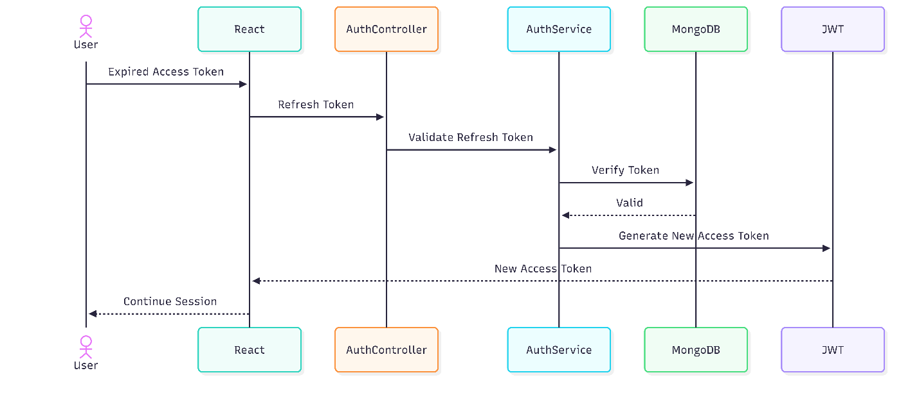
- Frontend sends the Refresh Token.
- Backend validates the Refresh Token.
- If valid, a new Access Token is generated.
- User continues the session without logging in again.

9.8 Role-Based Authorization
The system supports multiple roles.
Administrator
Permissions include:
- Manage users
- Access administrative endpoints
- Monitor the system
User
Permissions include:
- Access personal profile
- Use protected user endpoints
- Update account information

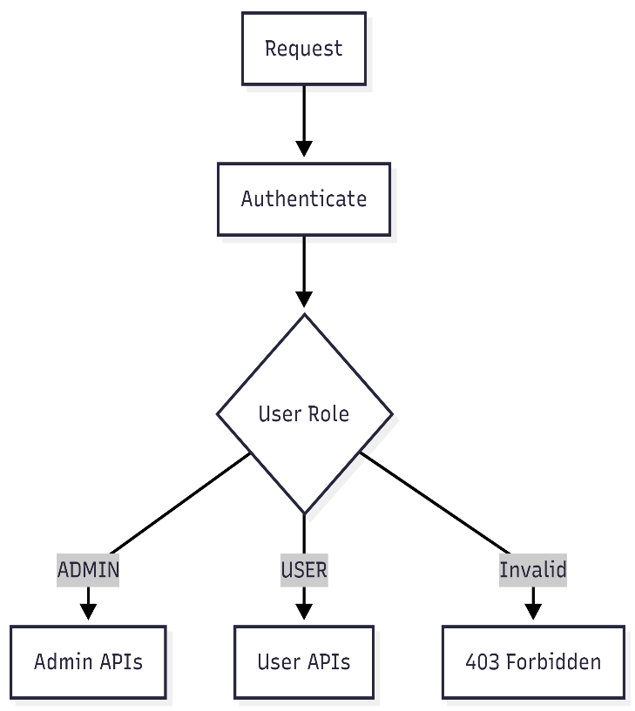
Authorization is enforced through Spring Security configuration and method-level security annotations.

Chapter 10 – Database Design
10.1 Overview
The system uses MongoDB, a NoSQL document-oriented database. Data is stored as JSON documents, allowing flexible schemas and efficient retrieval.

10.2 Users Collection
Stores registered user information.
Field | Type | Description
id | ObjectId | Unique identifier
firstName | String | User's first name
lastName | String | User's last name
email | String | Unique login email
password | String | BCrypt hashed password
role | Enum | User role (ADMIN, USER)
enabled | Boolean | Indicates if the account is active
emailVerified | Boolean | Email verification status
createdAt | Date | Account creation timestamp
updatedAt | Date | Last modification timestamp

10.3 Refresh Tokens Collection
Stores active refresh tokens.
Field | Type | Description
id | ObjectId | Token identifier
userId | ObjectId | Associated user
token | String | Refresh token
expiryDate | Date | Expiration time
revoked | Boolean | Revocation status

10.4 Email Verification Tokens Collection
Stores verification tokens.
Field | Type | Description
id | ObjectId | Token identifier
userId | ObjectId | Associated user
token | String | Verification token
expiryDate | Date | Expiration time

10.5 Password Reset Tokens Collection
Stores password reset requests.
Field | Type | Description
id | ObjectId | Token identifier
userId | ObjectId | Associated user
token | String | Reset token
expiryDate | Date | Expiration time

10.6 Entity Relationship (Conceptual)
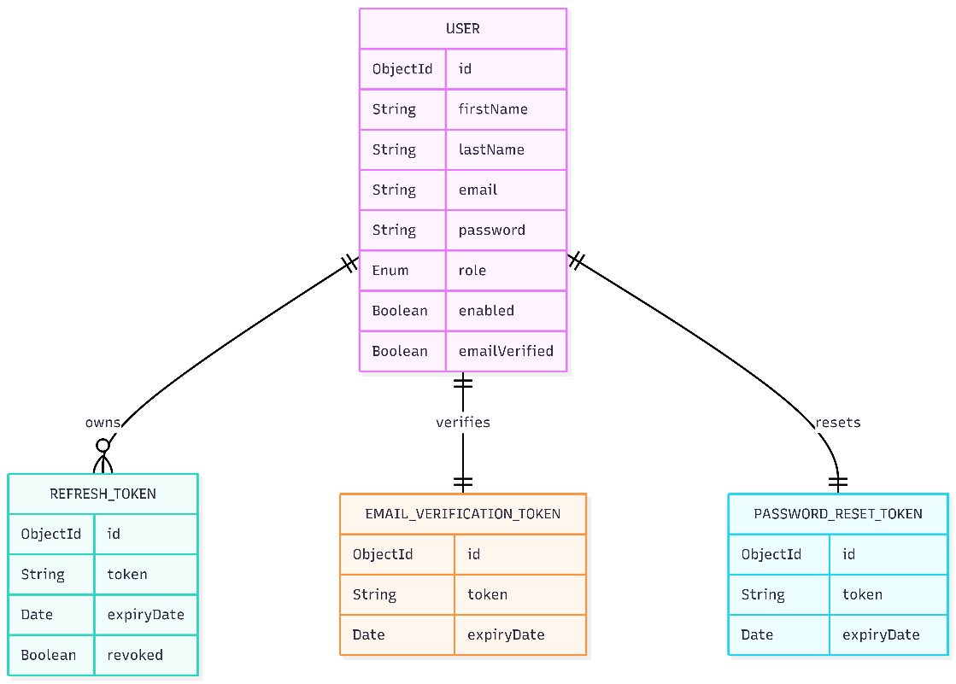
Each user can have:
- One or more refresh tokens (depending on your implementation).
- One active email verification token.
- One active password reset token.

10.7 Database Indexing
To improve query performance and maintain data integrity, MongoDB indexes are applied to frequently queried fields.
Indexed fields include:
- Email address (unique).
- Verification token.
- Refresh token.
- Password reset token.
These indexes reduce authentication latency while ensuring uniqueness where required.

Chapter 11 – Backend Design
11.1 Introduction
The backend of the Secure Authentication and Authorization System is developed using Spring Boot 3 with Java 21. The application follows a layered architecture that separates responsibilities into distinct components, improving maintainability, scalability, readability, and testability.
The backend exposes RESTful APIs that communicate with the React frontend while ensuring that every protected endpoint is secured using Spring Security and JWT authentication.
The architecture follows the principles of Separation of Concerns (SoC) and Dependency Injection (DI).

11.2 Backend Architecture
The backend is divided into multiple layers.
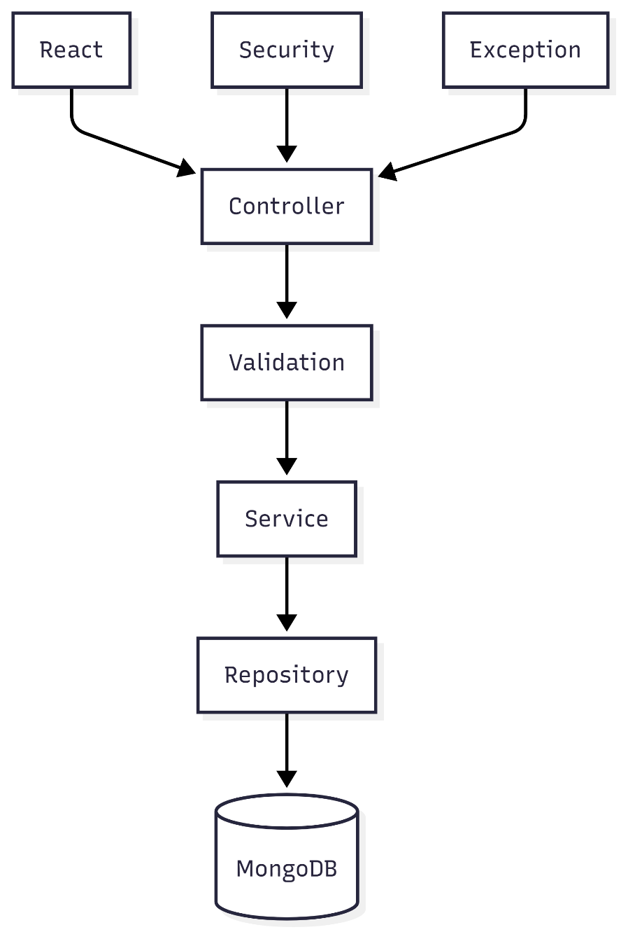
11.3 Package Structure
src
└── main
├── controller
├── service
├── repository
├── model
├── dto
├── security
├── config
├── exception
├── util
├── validation
└── mail
Each package has a single responsibility.

11.4 Controller Layer
The Controller Layer acts as the entry point for all HTTP requests.
Responsibilities:
- Receive client requests
- Validate request bodies
- Call business services
- Return HTTP responses
- Return appropriate status codes
Example responsibilities include:
- User Registration
- User Login
- Refresh Token
- Email Verification
- Forgot Password
- Password Reset
- Profile APIs
Example:
POST /api/auth/register

↓

RegisterController

↓

AuthService

11.5 Service Layer
The Service Layer contains the business logic.
Responsibilities
- Register users
- Authenticate users
- Generate JWT
- Generate Refresh Tokens
- Encrypt passwords
- Send verification emails
- Reset passwords
- Validate tokens
The service layer prevents controllers from containing business logic.

11.6 Repository Layer
The Repository Layer communicates directly with MongoDB.
Responsibilities
- Save User
- Find User by Email
- Find User by ID
- Save Refresh Token
- Save Verification Token
- Save Password Reset Token
- Delete Expired Tokens
Spring Data MongoDB automatically generates database queries.

11.7 DTO Layer
DTO (Data Transfer Objects) separate API requests from database entities.
Benefits
- Input validation
- Improved security
- Better maintainability
- Prevent exposing database models
Common DTOs
- RegisterRequest
- LoginRequest
- LoginResponse
- RefreshTokenRequest
- ForgotPasswordRequest
- ResetPasswordRequest
- UserResponse

11.8 Model Layer
Models represent MongoDB collections.
Example models
- User
- RefreshToken
- VerificationToken
- PasswordResetToken
Each model contains:
- Fields
- Constructors
- Getters
- Setters
- Validation annotations

11.9 Security Package
The Security package is the most important module.
Contains:
- Security Configuration
- JWT Filter
- JWT Provider
- UserDetailsService
- AuthenticationEntryPoint
- Password Encoder
- Security Constants
Responsibilities
- Validate JWT
- Authenticate users
- Configure Spring Security
- Protect APIs
- Handle unauthorized requests

11.10 Security Configuration
The Security Configuration class defines the application's authentication and authorization rules using Spring Security.
Major responsibilities include:
- Configuring the Security Filter Chain.
- Disabling server-side sessions using Stateless Session Management.
- Configuring endpoint authorization rules.
- Registering the Authentication Provider.
- Configuring Password Encoder.
- Registering JWT Authentication Filter.
- Configuring CORS policies.
- Enabling secure HTTP headers.

11.11 Password Encoding
Password security is implemented using BCrypt Password Encoder. User passwords are never stored in plain text. During authentication, the submitted password is compared against the stored BCrypt hash.
BCrypt provides:
- Automatic salt generation.
- Adaptive hashing.
- Resistance against rainbow table attacks.
- Strong password protection.

11.12 Exception Handling
The application implements centralized exception handling.
Benefits
- Consistent API responses
- Easier debugging
- Better client-side error handling
Common exceptions
- UserNotFoundException
- InvalidTokenException
- TokenExpiredException
- EmailAlreadyExistsException
- AccessDeniedException

Chapter 12 – Frontend Design
12.1 Introduction
The frontend is developed using React.js and provides a responsive interface for authentication operations.
The frontend communicates with the backend using Axios.

12.2 Folder Structure
src
│
├── components
├── pages
├── context
├── services
├── hooks
├── api
├── utils
├── assets
└── styles

12.3 Pages
Login Page
Purpose
Authenticate existing users.
Features
- Email input
- Password input
- Validation
- Remember Me (if implemented)
- Login button

Registration Page
Purpose
Create new user accounts.
Features
- User information
- Email
- Password
- Confirm Password
- Validation

Forgot Password
Purpose
Allow users to request password reset emails.

Reset Password
Purpose
Allow users to create a new password using a secure reset token.

Email Verification
Purpose
Verify newly created accounts before activation.

Dashboard
Displays authenticated user information after successful login.

12.4 React Components
Examples
- Navbar
- Footer
- ProtectedRoute
- Loading Spinner
- Form Input
- Button
- Alert
- Modal
Reusable components reduce duplicate code.

12.5 Authentication Context
React Context stores:
- Logged-in User
- JWT Access Token
- Authentication State
- User Role
Benefits
- Global state management
- Cleaner components
- Easier authentication

12.6 Axios Service
Axios handles communication with backend APIs.
Responsibilities
- Send requests
- Attach JWT Authorization header
- Handle unauthorized responses
- Refresh expired tokens (if implemented)

12.7 Protected Routes
Only authenticated users can access protected pages.
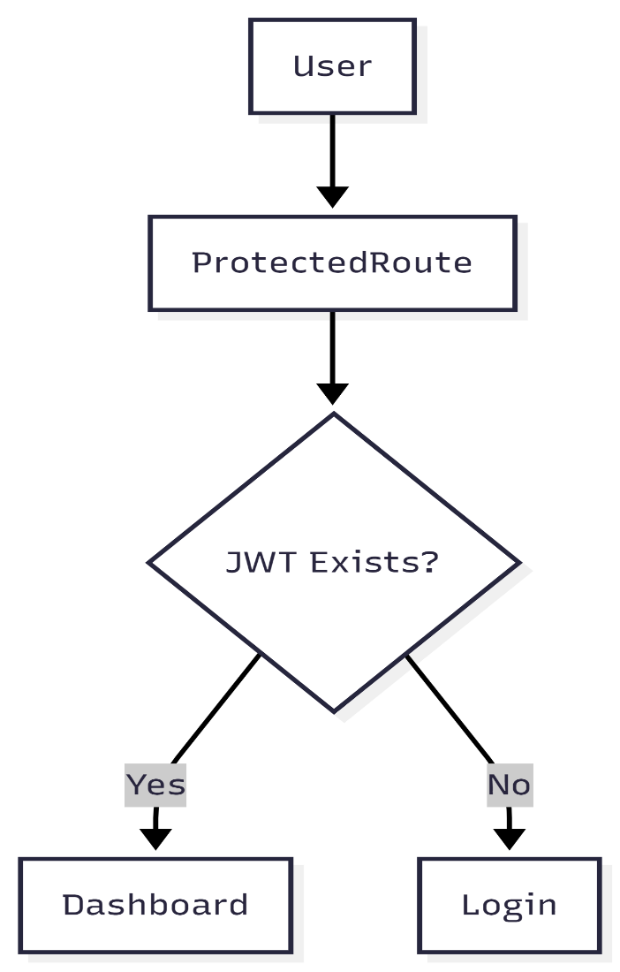
Chapter 13 – REST API Documentation
13.1 Overview
The backend exposes RESTful APIs secured using Spring Security.
All APIs communicate using JSON.

Authentication APIs
Register User
POST /api/auth/register
Request:
{
"firstName":"John",
"lastName":"Doe",
"email":"john@gmail.com",
"password":"Password123!"
}

Response:
{
"message":"Registration successful. Please verify your email."
}

Login
POST /api/auth/login
Request:
{
"email":"john@gmail.com",
"password":"Password123!"
}
Response:
{
"accessToken":"jwt-token",
"refreshToken":"refresh-token",
"expiresIn":900
}

Refresh Token
POST /api/auth/refresh
Request:
{
"refreshToken":"token"
}
Response:
{
"accessToken":"new-token"
}

Verify Email
GET /api/auth/verify?token=xxxxx
Response:
{
"message":"Email verified successfully"
}

Forgot Password
POST /api/auth/forgot-password

Reset Password
POST /api/auth/reset-password

Logout
POST /api/auth/logout

User APIs
Get Profile
GET /api/users/profile
Authorization Required
Bearer Token

Update Profile
PUT /api/users/profile

Admin APIs
Examples
GET /api/admin/users
DELETE /api/admin/users/{id}

13.2 Endpoint Authorization Matrix
Endpoint | Access Level
POST /api/auth/register | Public
POST /api/auth/login | Public
POST /api/auth/refresh | Public
GET /api/auth/verify | Public
POST /api/auth/forgot-password | Public
POST /api/auth/reset-password | Public
GET /api/users/profile | Authenticated User
PUT /api/users/profile | Authenticated User
GET /api/admin/** | Administrator
DELETE /api/admin/** | Administrator

Common HTTP Status Codes
Code | Meaning
200 | OK
201 | Created
400 | Bad Request
401 | Unauthorized
403 | Forbidden
404 | Not Found
409 | Conflict
500 | Internal Server Error

Chapter 14 – Security Features
Security is the primary focus of this system.

14.1 JWT Authentication
Instead of server sessions, authentication uses JWT tokens.
Advantages
- Stateless
- Fast
- Scalable
- Secure

14.2 Refresh Tokens
Refresh Tokens allow users to obtain new access tokens without logging in again.
Benefits
- Better user experience
- Short-lived access tokens
- Improved security

14.3 BCrypt Password Hashing
Passwords are hashed before storage.
Advantages
- Salt generation
- One-way encryption
- Resistant to rainbow table attacks

14.4 Spring Security
Spring Security protects every secured endpoint.
Responsibilities
- Authentication
- Authorization
- Session policy
- Security filters

14.5 HTTP Security Headers
The application configures secure HTTP response headers to protect against common browser-based attacks.
Implemented headers include:
- Content Security Policy (CSP) to reduce Cross-Site Scripting (XSS) risks.
- HTTP Strict Transport Security (HSTS) to enforce secure HTTPS communication.
- X-Frame-Options to prevent Clickjacking attacks.
- Secure cache control headers where applicable.
These headers provide an additional layer of protection beyond authentication and authorization.

14.5 Role-Based Authorization
Only authorized users can access protected APIs.
Example
ADMIN

↓

Can Access

/api/admin/**

USER

↓

Cannot Access

14.6 Email Verification
New accounts remain inactive until the user verifies their email.
Benefits
- Prevent fake accounts
- Validate email ownership
- Improve security

14.7 Password Reset Tokens
Secure reset tokens expire after a configurable duration.
Benefits
- Temporary access
- Reduced risk of misuse

14.8 Input Validation
Every request is validated before processing.
Examples
- Email format
- Password length
- Required fields
- Null checks

14.9 Exception Handling
The system returns standardized JSON responses for errors.
Example
{
"timestamp":"2026-07-08T12:30:10",
"status":401,
"error":"Unauthorized",
"message":"Invalid JWT Token"
}

14.10 CORS Configuration
Cross-Origin Resource Sharing is configured to allow only trusted frontend origins.
Benefits
- Prevent unauthorized browser requests
- Improve API security

14.11 Rate Limiting
The backend limits excessive requests to sensitive endpoints such as:
- Login
- Registration
- Forgot Password
Benefits
- Protect against brute-force attacks
- Reduce abuse
- Improve availability

14.12 Request Validation
All incoming client requests undergo validation before business logic execution. Validation rules are implemented using Jakarta Bean Validation annotations within Data Transfer Objects (DTOs).
Validation includes:
- Required field validation.
- Email format validation.
- Password complexity checks.
- Null value prevention.
- Request body validation.
Invalid requests return standardized HTTP 400 (Bad Request) responses.

14.13 Standardized API Responses
The backend returns standardized JSON responses for both successful and unsuccessful requests to ensure consistency across all REST APIs.
Successful responses include:
- Status code.
- Response message.
- Requested data.
Error responses include:
- Timestamp.
- HTTP status.
- Error description.
- Detailed message.

14.14 Brute Force Protection
To reduce the risk of brute-force attacks, sensitive endpoints such as user login, registration, and password recovery are protected using request rate limiting. Excessive requests from the same client within a configured time window are temporarily blocked.
This mechanism provides protection against:
- Password guessing attacks.
- Credential stuffing.
- Automated login attempts.
- Denial-of-Service attempts targeting authentication endpoints.

14.15 Swagger Security
Swagger/OpenAPI is configured to support Bearer Token authentication, allowing developers to test secured endpoints directly from the API documentation interface.

14.16 Overall Security Workflow
